.
Got to Be NC Food, Wine & Beer Expo Application
N.C. Dept. of Agriculture
1020 Mail Service Center
Raleigh, NC 27699

For more Information, contact:
Myrtle Earley
Myrtle.earley@ncagr.gov
Phone - 919-707-3118
Fax – 919-715-0155

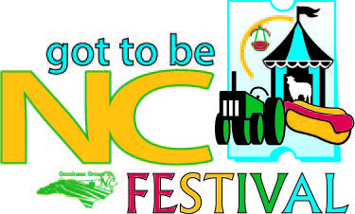

APPLICATION for Space in Got to Be NC Food, Wine & Beer EXPO May 17-19, 2013
Note: Applicants MUST be a member of Goodness Grows in North Carolina.

Please Print.
Company Name: _________________________________________________________________________________

Name & Title of Applicant: ________________________________________________________________________

Mailing Address: _________________________________________________________________________________

City:________________________________________State___________Zip__________________________________

Phone:_______________Cell _____________________Fax_____________________Email:____________________

Please list all products to be sampled and sold at Food Expo. List all items including brand names if applicable. Items must be made in NC.
________________________________________________________________________________________________________________________________________________________________________________________________________________________________________________________________________________________________
Booth spaces include one draped and skirted 8’ table, 1- 8’ table with no skirting, carpet, 3’ pipe and drape on booth sides, 8’ back pipe and drape behind booth, 2 chairs and a 110 volt 20 amp electrical hook-up.

One 10’x 10’ space is $150. Additional booths are $125 each. Corner Booths are $200.
Indicate the number of 10’ x 10’ spaces needed. Only 1 corner booth per company.

_______Regular Booth ($150 each) _________Additional Booth ($125 each) ________Corner Booth ($200 each)

All booths have electrical outlets. If you need additional electrical, please complete,
Advanced Electrical Hook-ups –indicate the # needed - ___________30/50AMP ($100 ea.) __________60/80AMP ($160 ea.)

Include my company in the 24 coupons. We will offer _________________________________________________.

Signature of Applicant________________________________________Date Submitted_______________________

Make Checks Payable to: NCDA & CS
Mail Checks to: Myrtle T. Earley, 1020 Mail Service Center, Raleigh, NC 27699
Payment Enclosed $________________

NO REFUNDS AFTER MAY 3, 2013.

