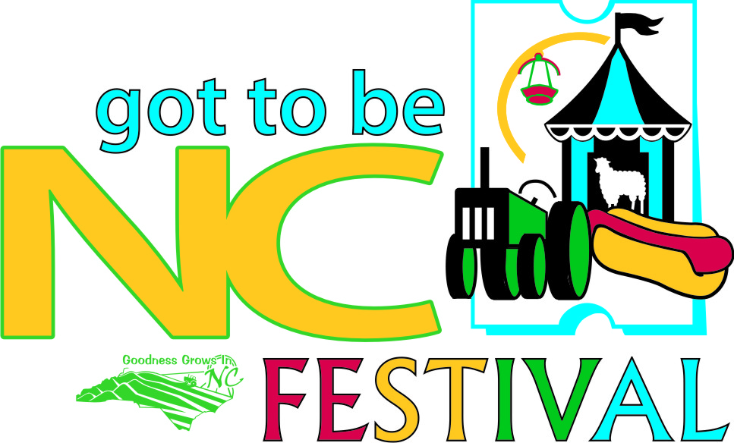
M E M O R A N D U M

To: Goodness Grows in NC Members and NC Commodity Associations

From: Myrtle T. Earley

Date: March 13, 2013

NCDA & CS would like to invite your company to exhibit in the Got to Be NC Food, Wine & Beer Expo, a part of the Got to Be NC Festival. This sixth annual Expo will take place in the Expo Building at the NC State Fairgrounds on May 17, 18, 19, 2013. Our goal is for 75,000 people to come to the festival during the 3 - day event. In our portion of the festival, attendance from the Food Expo in 2013 was over 25,000 people. The doors will be open to the public on Friday from Noon – 8:00pm, Saturday from 10:00am – 8:00pm and Sunday from 10:00am – 6:00pm. Gate admission to the Food Expo will be $2.for all over 11 years old. To offset the admission charge, we are offering the opportunity to 24 exhibiting companies to offer a coupon with a minimum value of $1. It could be $1 or more off purchase, buy two get one free, 10% off case purchase, etc., but the minimum value would be $1 per coupon. The first 24 exhibitors who agree to this will be on a coupon sheet, printed by NCDA and given to all paying adults. This opportunity will help drive customers to your booth. We are working on several ideas to drive more qualified consumers to the show on Friday. We also have had some response in the past from some local retailers visiting the show.

This show gives companies an opportunity to sample and sell products to consumers. We welcome produce, meat, condiments, snacks, desserts, pickles, jams, jellies, beverages, frozen items, breads, sauces, wines, beer etc. as vendors. However, prepared foods such as sandwiches, entrees, etc, may not be sold. Wineries are welcome to sample and sell by the bottle ONLY for off-premise consumption. The breweries may sell 6 packs, individual growlers or bombers ONLY for off-premise consumption.

The 10’ x 10’ booths are $150. Corner booths are $200. Additional booths are $125 each. Booth spaces include one draped and skirted 8’ table, one 8’ table that is not covered or skirted, carpet, 3’ pipe and drape on booth sides, 8’ pipe and drape behind the booth, a 110 volt 20 amp electrical outlet and 2 chairs.

All companies participating in the Expo are required to provide a General Liability Insurance certificate with a minimum coverage of $1,000,000. A Certificate of Insurance afforded by a company licensed to do business in North Carolina must be provided naming NC Ag Promotions as the certificate holder and : NC State Fair and NCAP as additional insured. The address of NC State Fair is 1025 Blue Ridge Rd, Raleigh, NC 27607. The address for NCAP is PO Box 27647, Raleigh, NC 27601.
To participate, complete the enclosed application and mail with a check and liability insurance certificate to: Myrtle T. Earley, PO Box 27647, Raleigh, NC 27611. Checks should be made payable to NCDA & CS. Questions should be directed to myrtle.earley@ncagr.gov or 919-707-3118.
No faxed applications please. All applications should be received with a check and the Certificate of Insurance.

